Synopsis

Air Quality Level Classification System

Problem Id: 19

Student Name- Suvidha Setia
University Roll number- 2028875
Section- K

Student Name- Saksham Mittal
University Roll number- 2028833
Section- K

Student Name- Nimisha Bhatt
University Roll number- 2028784
Section- K

- Problem Description:
- Air pollution has become a major environmental issue affecting human health, climate, and ecosystems. Rapid industrialization, urbanization, and increasing vehicle emissions have significantly increased pollution levels in many regions.
- Poor air quality can cause serious health problems such as asthma, respiratory diseases, lung infections, and other long-term health issues. It also harms plants, animals, and disturbs the ecological balance.
- To monitor pollution levels, environmental monitoring systems collect data from sensors measuring parameters such as Carbon Monoxide (CO), Nitrogen Dioxide (NO₂), temperature, and humidity.
- However, these systems generate large volumes of data continuously, making manual analysis difficult, time-consuming, and inefficient.
- Traditional monitoring methods often struggle to provide quick and accurate classification of air quality levels, which can delay important decisions related to pollution control.
- To solve this problem, machine learning techniques can be used to automatically analyze environmental data and identify patterns in pollution levels.
- Using algorithms such as K-Nearest Neighbors (KNN) and Logistic Regression, the system can classify air quality into categories like Good, Moderate, Poor, or Severe.
- This automated system can support real-time pollution monitoring, smart city systems, and better environmental decision-making.

- Steps of Implementation:
Data Collection- Load air quality dataset containing pollutants like CO, NO₂, PM2.5 and other environmental attributes.
Data Preprocessing- Handle missing values, remove unnecessary columns, and clean noisy data.
Feature Selection- Select important pollution indicators that contribute most to AQI prediction.
Data Scaling- Normalize numeric values using scaling techniques to improve model performance.
Model Training- Train classification models such as KNN and Logistic Regression.
Model Testing- Test the trained model on unseen data to evaluate prediction performance.
Evaluation- Use evaluation metrics like accuracy and precision to measure model effectiveness.

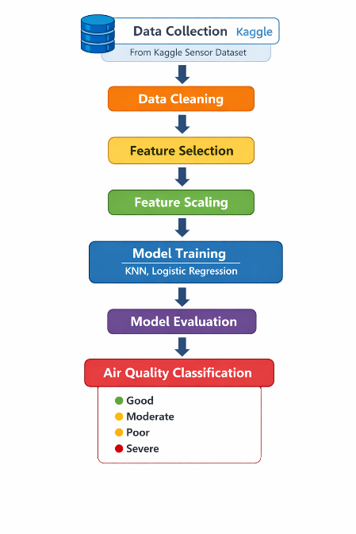Fig1. Architecture
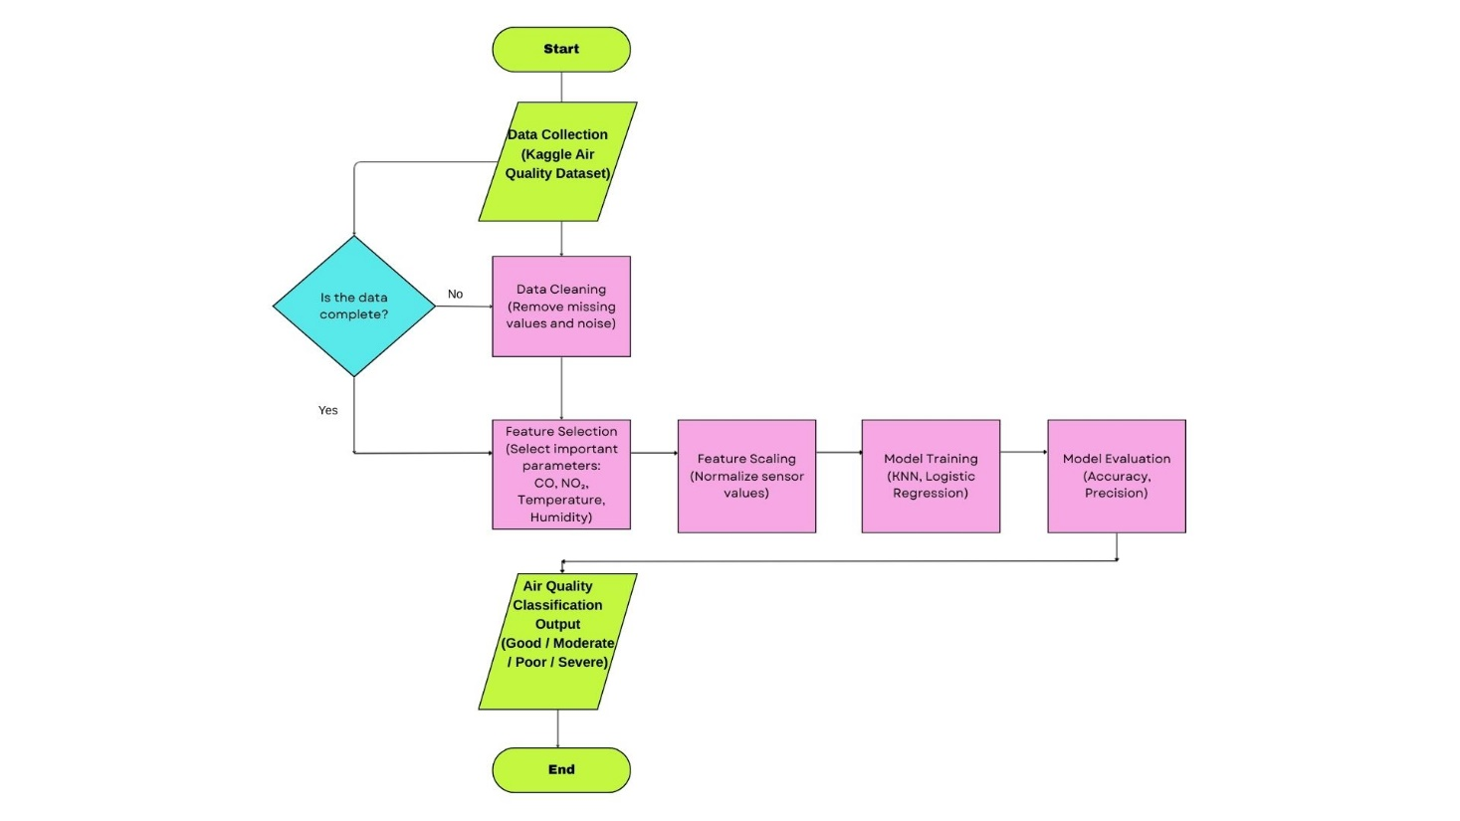
Fig.2 Workflow Diagram Flowchart

- Expected Modules/ Libraries to be used :
NumPy:
A numerical computing library used to perform mathematical operations on arrays and matrices efficiently.
Pandas:
A powerful data manipulation library used for reading datasets, cleaning data and handling tabular data structures like DataFrames.
Matplotlib:
A visualization library used to create graphs, charts and plots for understanding patterns in air quality data.
Seaborn:
A statistical visualization library built on top of Matplotlib which helps in creating more informative plots.
Scikit-learn:
A machine learning library that provides algorithms such as KNN and Logistic Regression along with tools for preprocessing and evaluation.

- Expected Evaluation metrics and Plots to be used:
Accuracy- Measures the percentage of correct predictions made by the model.
Precision- Evaluates how many predicted positive observations are actually correct.
Confusion Matrix- Helps visualize classification performance by showing correct and incorrect predictions.
Visualization Plots- Correlation heatmaps, feature distribution plots, and model comparison graphs will be used to understand the dataset and model performance.

- Required topics from the subject:
Strings- Used for handling categorical labels such as AQI categories.
Files- Reading and writing dataset files such as CSV format.
Data Structures / Arrays- Used for storing and processing numerical sensor data.

- Platform Required:
Python Jupyter Notebook, Google Colab, Visual Studio Code for implementing and testing machine learning models.

- Books and Link Sources:
Hands-On Machine Learning with Scikit-Learn, Keras & TensorFlow- Aurélien Géron.
Introduction to Machine Learning with Python- Andreas C. Müller.
https://scikit-learn.org
https://pandas.pydata.org
https://www.kaggle.com (Air Quality datasets)

